**Screenshots below. Interactive only through links.**

First picture = [location numbers](https://fortress.maptive.com/ver4/f98d27765c3170ef4fd81b050afcfa23)

Second picture = [hurricane wind speed heat map](https://fortress.maptive.com/ver4/9efaf9ecb9a022bc265b7681d62adaf2/683420)

Third picture = [locations by frequency risk](https://fortress.maptive.com/ver4/d2edc38c0335625062204d1c19531c5f)

**TIV Maps:**

1. [Link](https://fortress.maptive.com/ver4/b26b244774bb92fa1b408fff92f8f59c)
2. [Link](https://fortress.maptive.com/ver4/bf25efc2b6fa60ddce817243622a9422)
3. [Link](https://fortress.maptive.com/ver4/870f1c33d37eb37707c3648ff33bf30d)
4. [Link](https://fortress.maptive.com/ver4/a745b9677cf5036831ac973bf4825b85)
5. [Link](https://fortress.maptive.com/ver4/5fda004de2e20afe52b13673b5f88d54)
6. [Link](https://fortress.maptive.com/ver4/e67f799f06f39912b399a5f04833fd91)
7. [Link](https://fortress.maptive.com/ver4/928f4771e6ab5903ba2f5d48e5327b3b)
8. [Link](https://fortress.maptive.com/ver4/8cffeeb21242a4b25ed40aaf0910bca1)
9. [Link](https://fortress.maptive.com/ver4/603c27e167c1d13fa199a584a69b1ca3)
10. [Link](https://fortress.maptive.com/ver4/7371a02f5859e80e516ed0f6def3fa9e)
11. [Link](https://fortress.maptive.com/ver4/77742b888ba1d4fc2a0e737c6a96ba53)
12. [Link](https://fortress.maptive.com/ver4/540f9d275ce71d0005652cfe5359b4d6)
13. [Link](https://fortress.maptive.com/ver4/0f14990be773d90e18bb0f19cb5dbbbd)
14. [Link](https://fortress.maptive.com/ver4/ce89cc4062aa9b9b8027df1913e8000b)
15. [Link](https://fortress.maptive.com/ver4/36d352e0d391d822c1f4e08bf6c7cfff)
16. [Link](https://fortress.maptive.com/ver4/071f97f69d056f2d072df7e88cc92f6f)
17. [Link](https://fortress.maptive.com/ver4/e4cf0355662b638a658081420ba39703)
18. [Link](https://fortress.maptive.com/ver4/81ed8f08d6b16bd091790660100bfa35)
19. [Link](https://fortress.maptive.com/ver4/9f24ef654712d5c9e6265466b0693f4f)
20. [Link](https://fortress.maptive.com/ver4/04aa0e53e32745fce87136eb4bf7cd8e)
21. [Link](https://fortress.maptive.com/ver4/b3fd7a473f7d680adbab60aa6c8cb6f8)
22. [Link](https://fortress.maptive.com/ver4/24beb5e63acbaffa3dddf32d361344ae)
23. [Link](https://fortress.maptive.com/ver4/f057bd3d99a6cb173e0a547439535f31)
24. [Link](https://fortress.maptive.com/ver4/79894734c1ca957f4bae6d93bd4c24ac)
25. [Link](https://fortress.maptive.com/ver4/b6104c8b1b900be8493476253b20a7ed)
26. [Link](https://fortress.maptive.com/ver4/5a1284e21f570bde8455acd76478c467)
27. [Link](https://fortress.maptive.com/ver4/6ca49e7a3910a461c21d644cc957c49d)
28. [Link](https://fortress.maptive.com/ver4/5483629b1773db15133f7285b2085dcb)
29. [Link](https://fortress.maptive.com/ver4/de2213ebeb67c333cba2d6bb3ed43f8e)
30. [Link](https://fortress.maptive.com/ver4/721d24794b33fd9ed953b6cf2425cfe2)
31. [Link](https://fortress.maptive.com/ver4/fde73025b3cfd054e180fe1f174c3102)
32. [Link](https://fortress.maptive.com/ver4/e19fd1676c8b8fc3ddc6a957d7eb12ab)
33. [Link](https://fortress.maptive.com/ver4/a93b91ab684d7f086e3dea69e1bde31a)
34. [Link](https://fortress.maptive.com/ver4/61f4f05c1c65008186bbc18275b9f799)
35. [Link](https://fortress.maptive.com/ver4/41479f1bfb8f02ff4b1f7a476117c0ac)
36. [Link](https://fortress.maptive.com/ver4/797d5c99b39eb7e6c55c72805ed327ce)
37. [Link](https://fortress.maptive.com/ver4/a0a9d36cc9d6902b1472e5112aa6c85a)



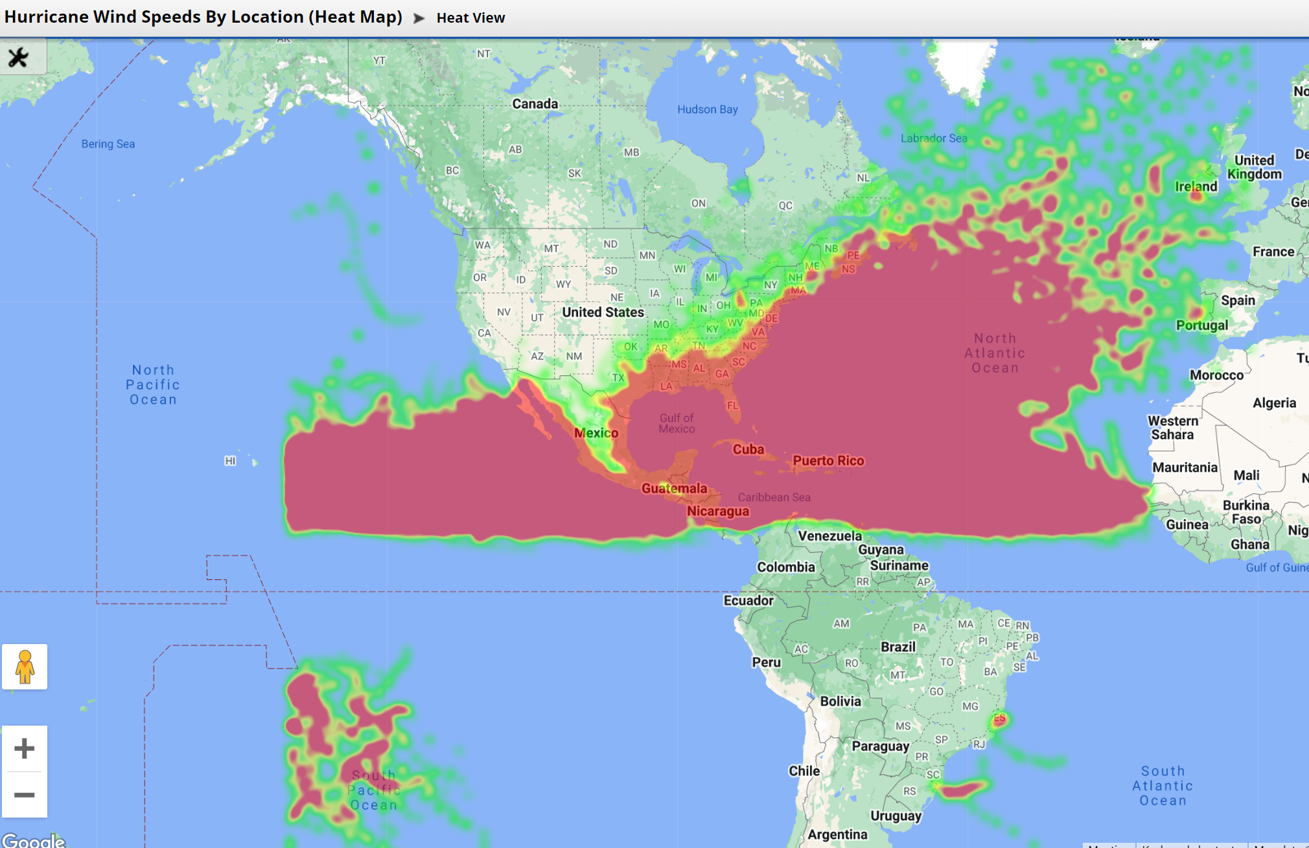

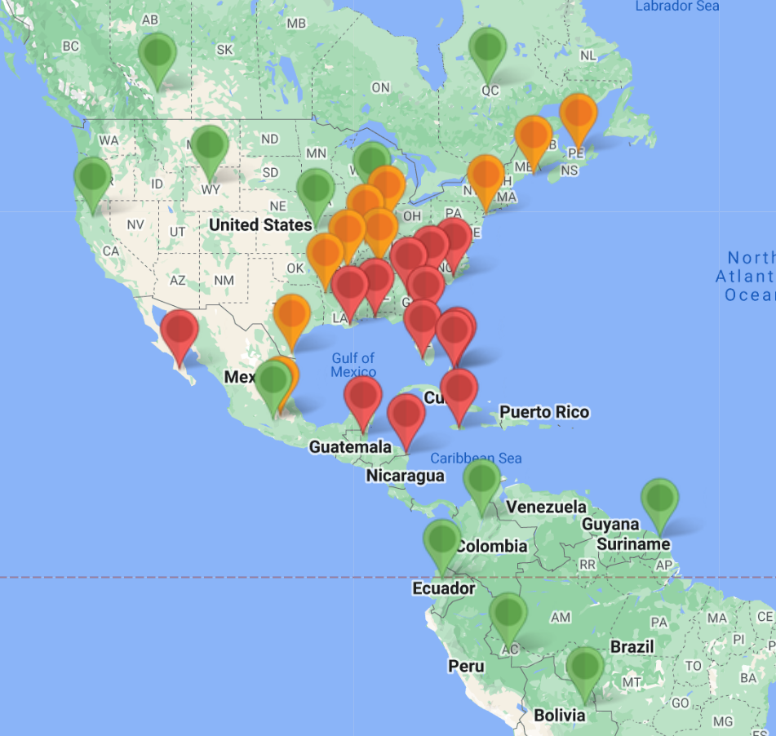

1. 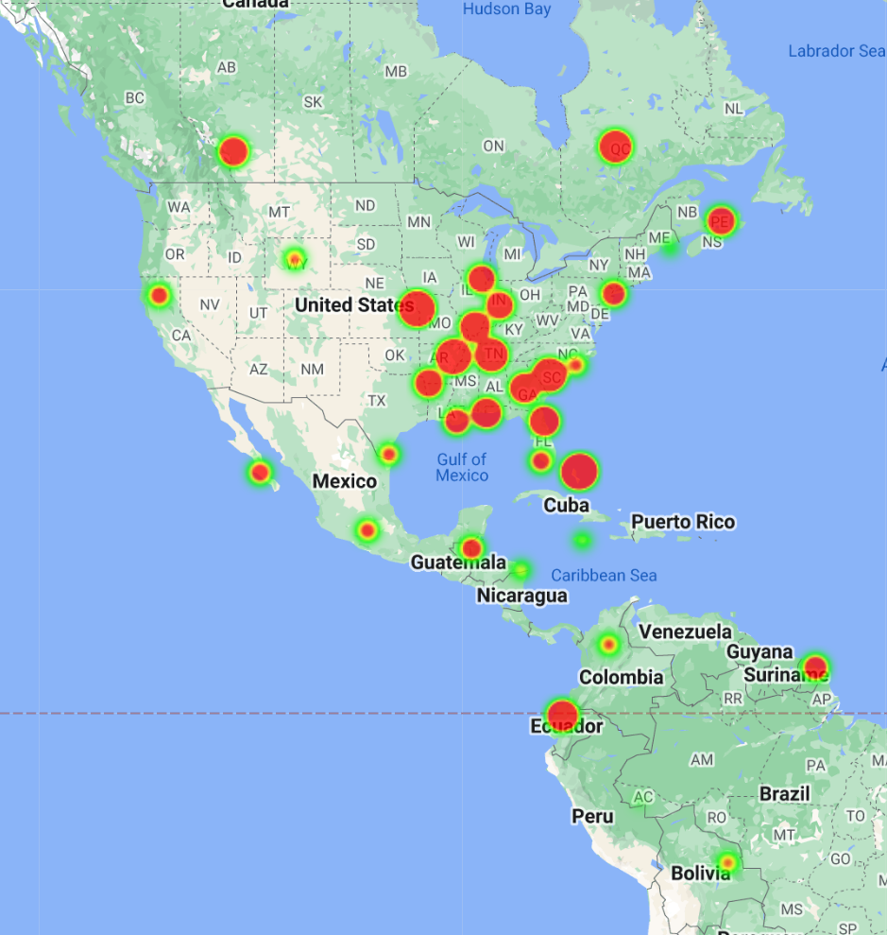
2. 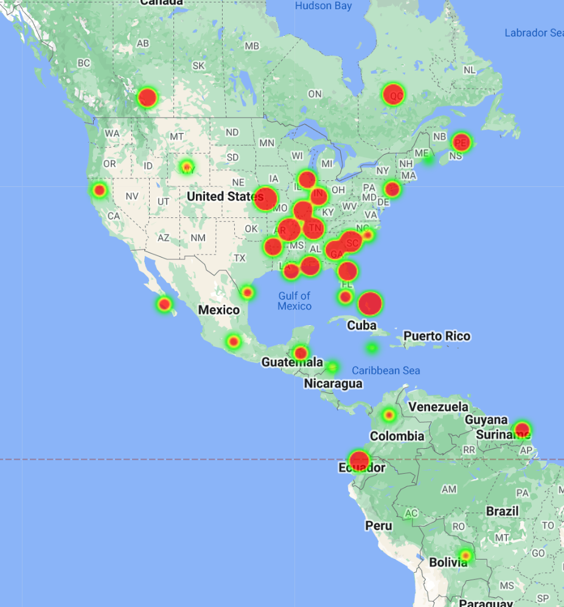
3. 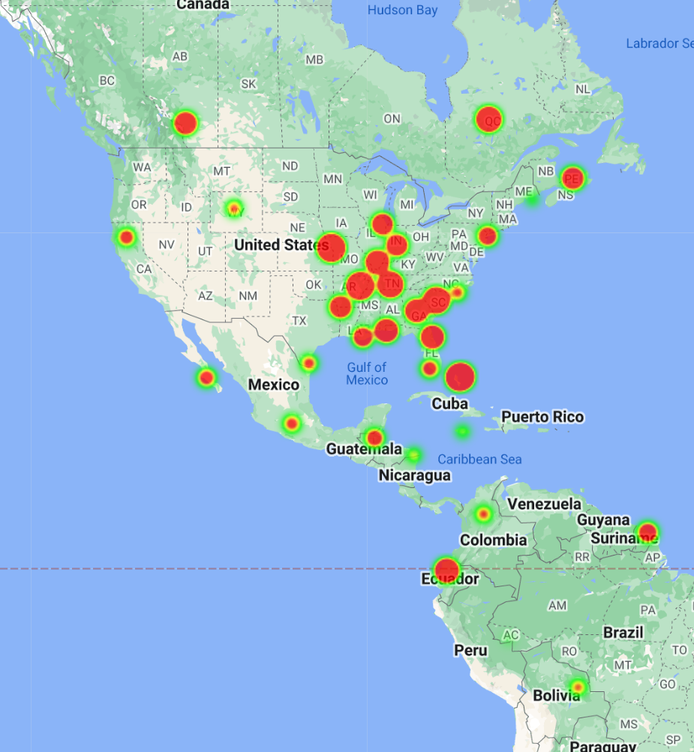
4. 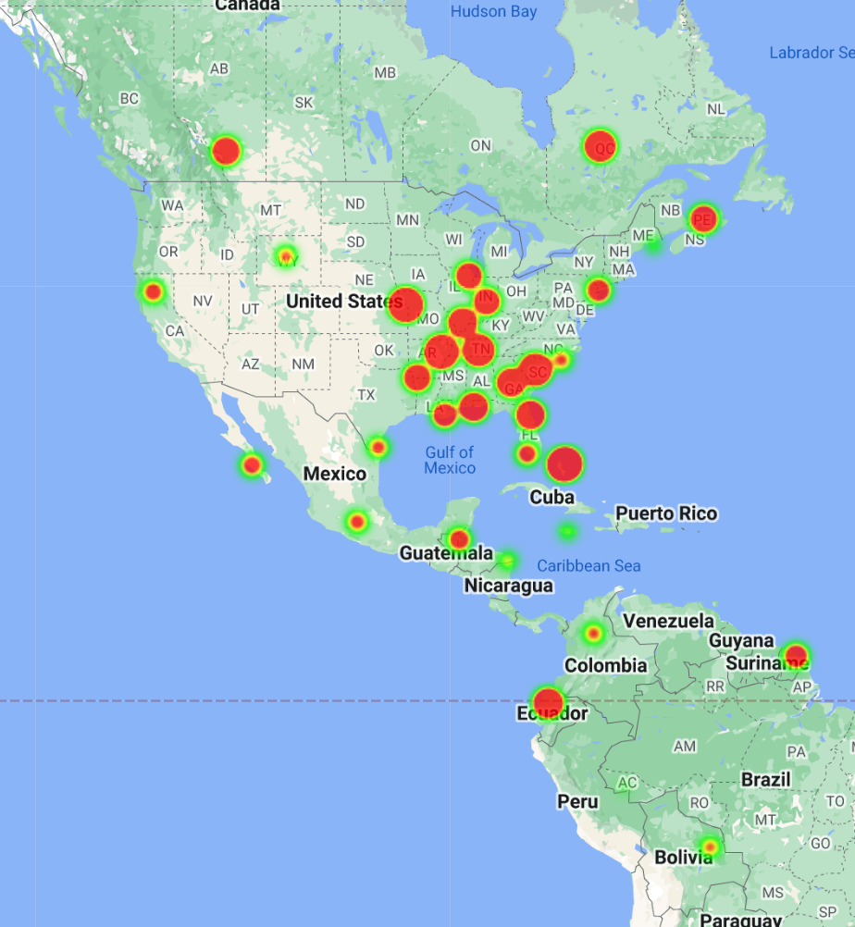
5. 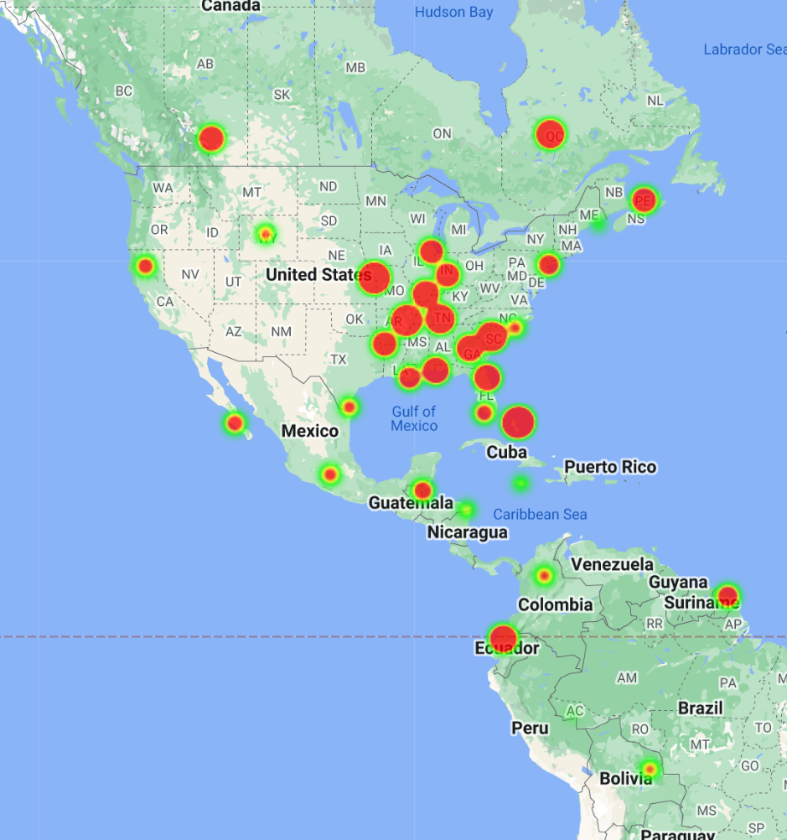
6. 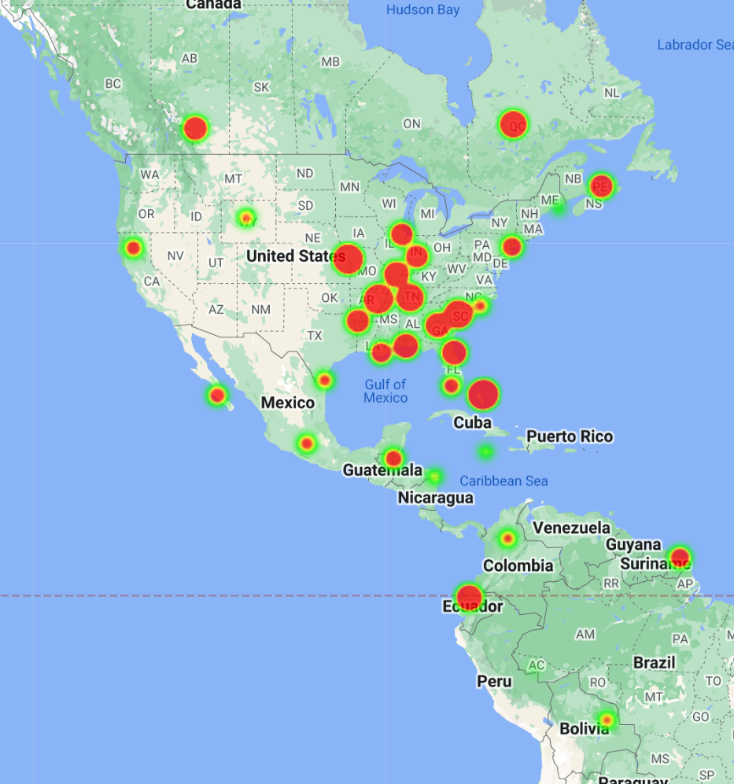
7. 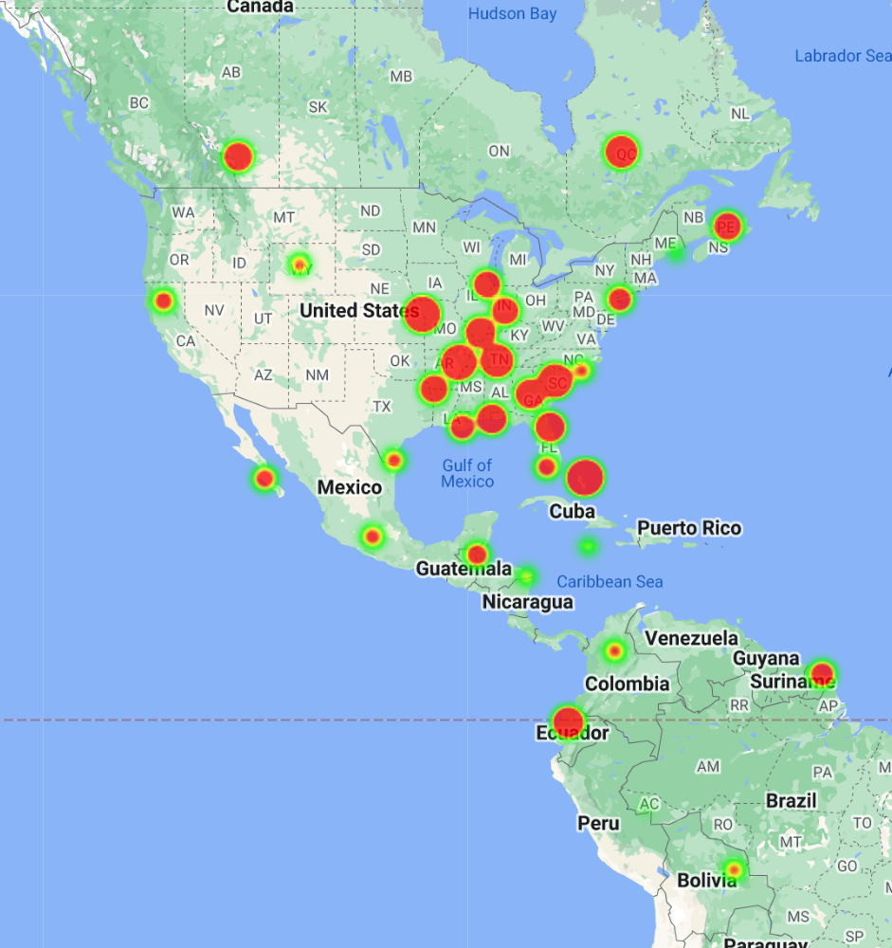
8. 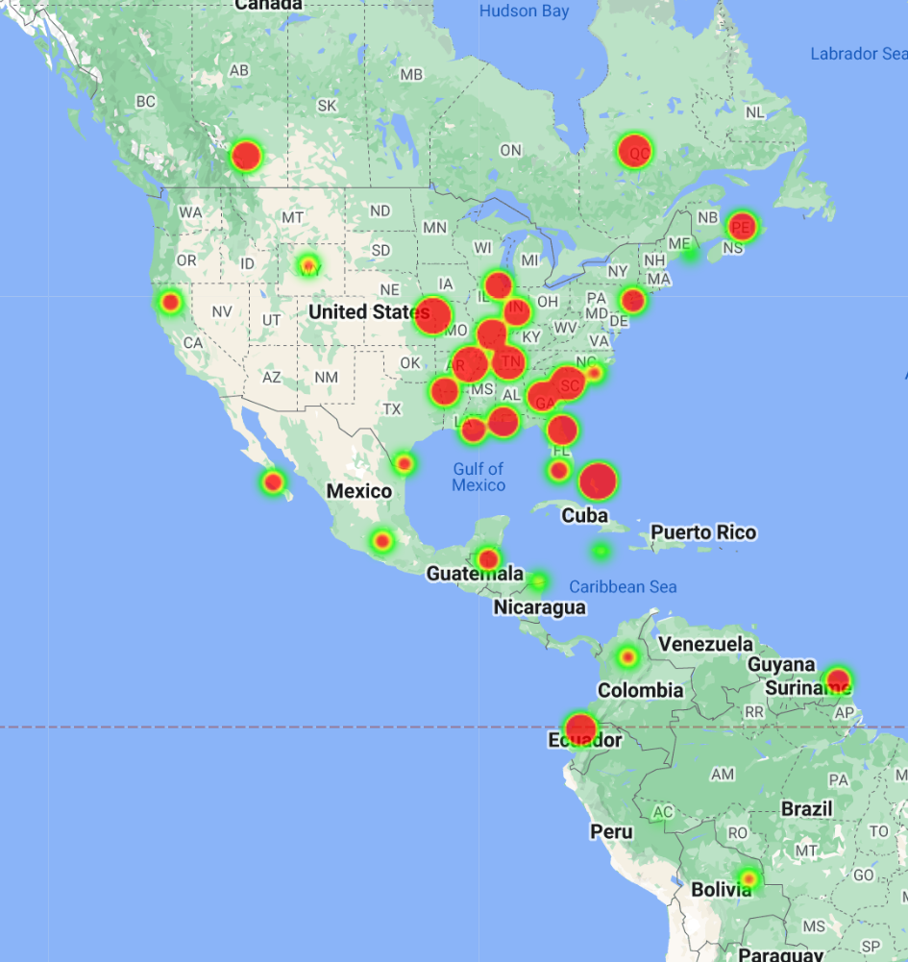
9. 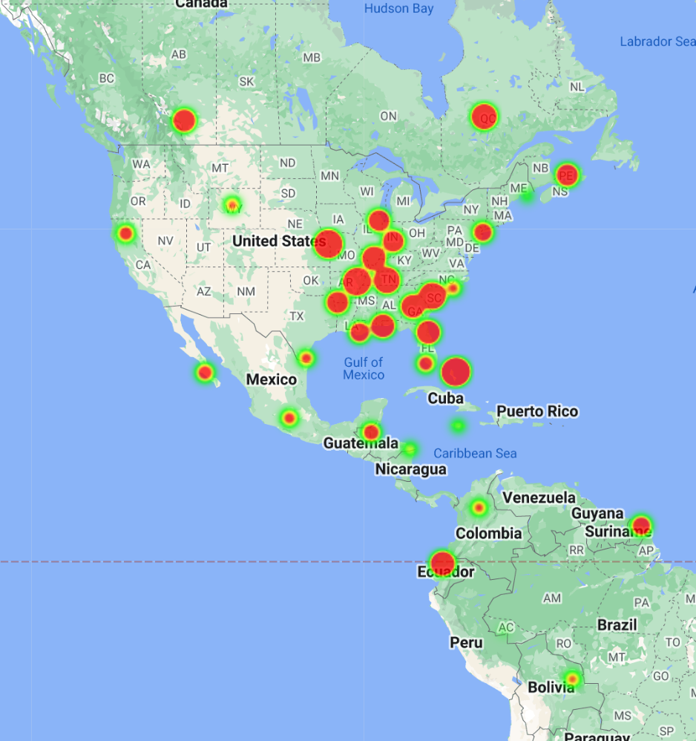
10. 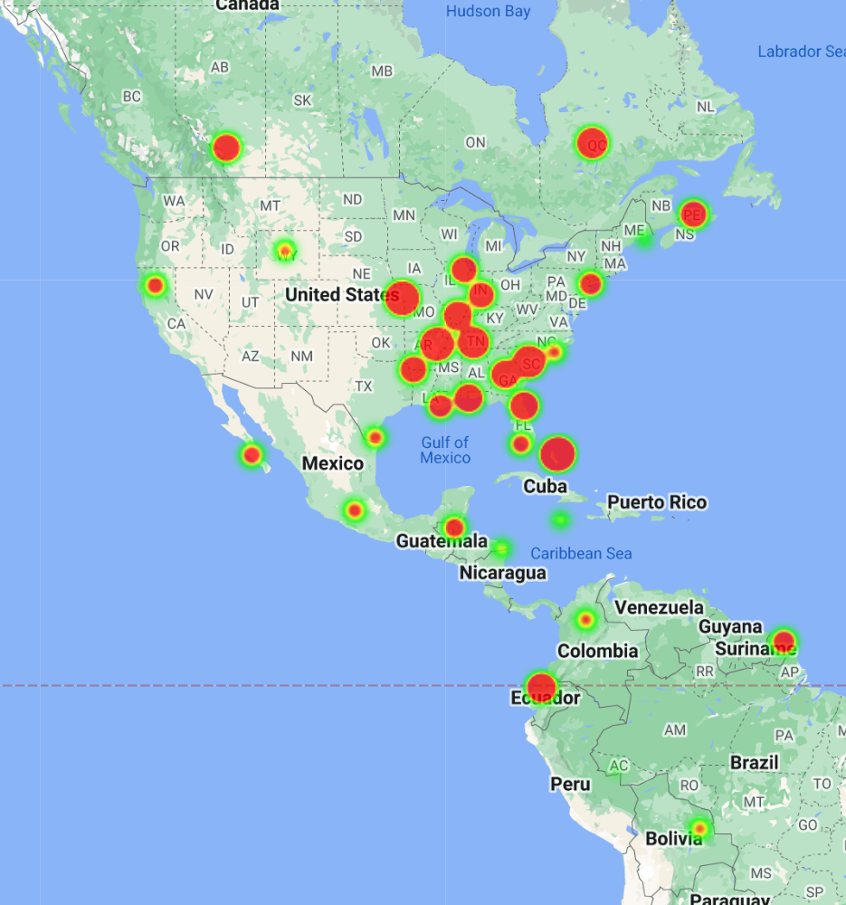
11. 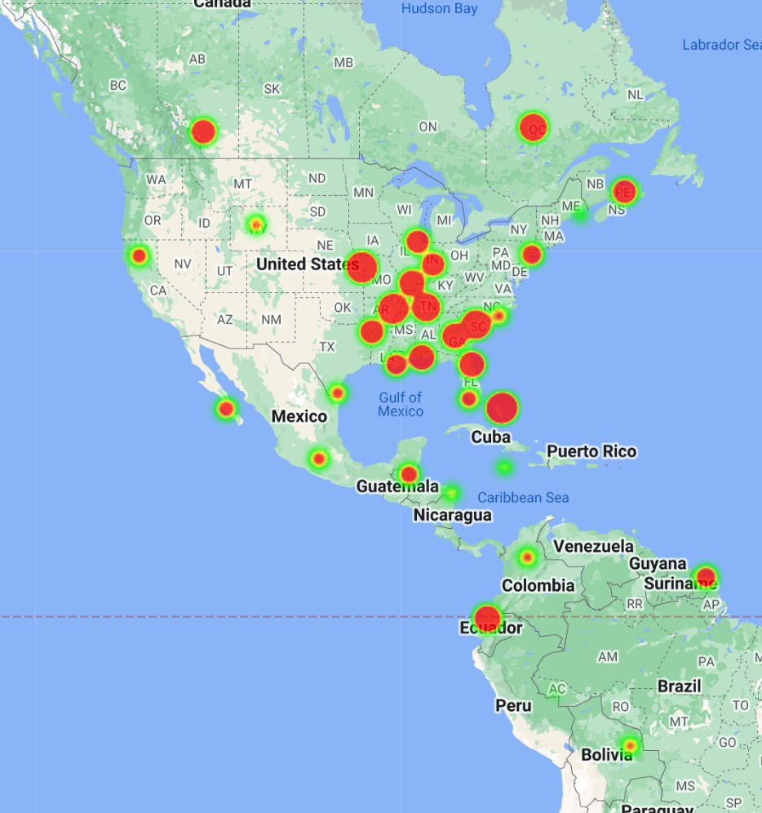
12. 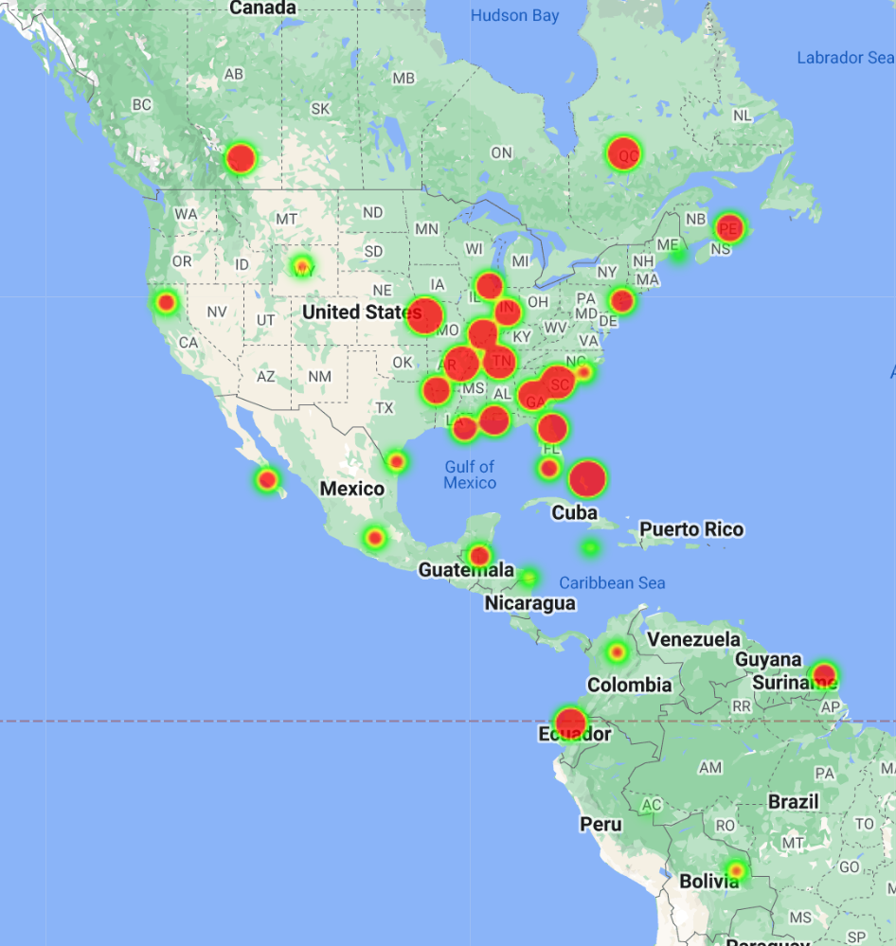
13. 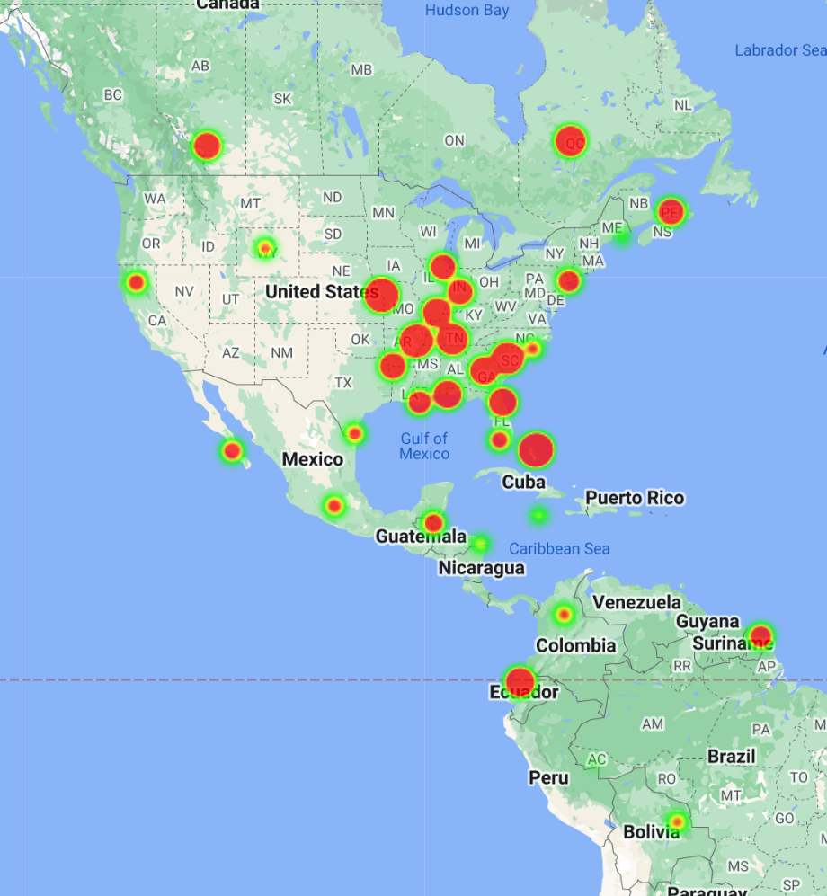
14. 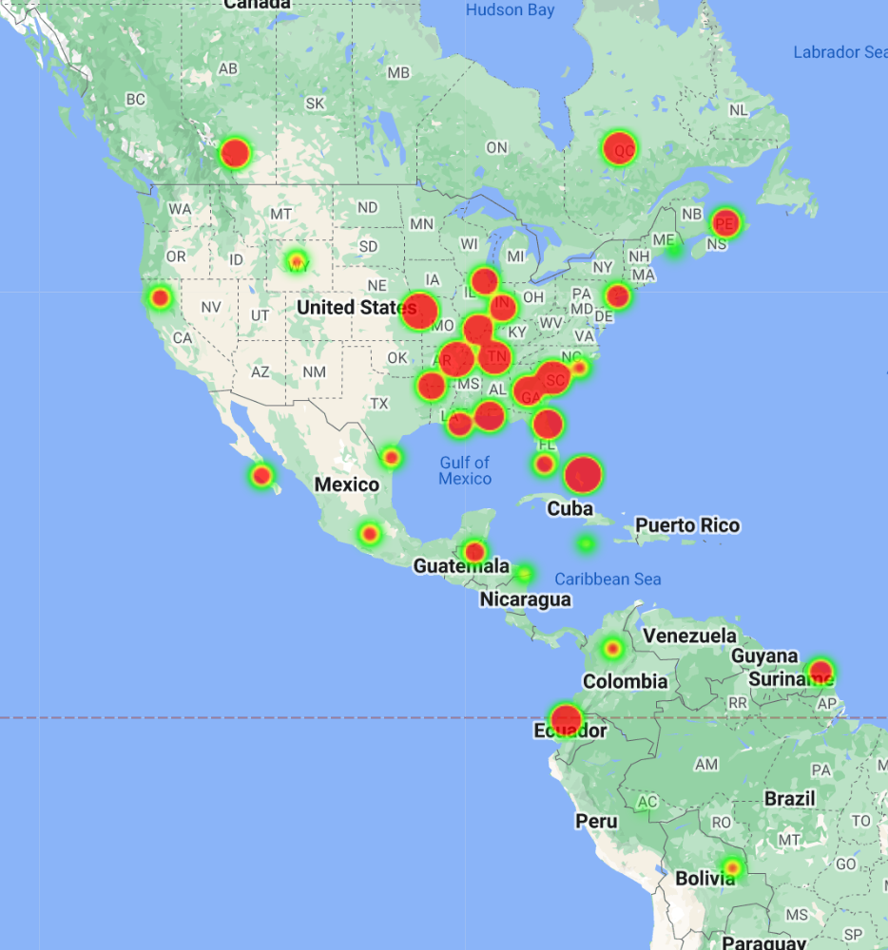
15. 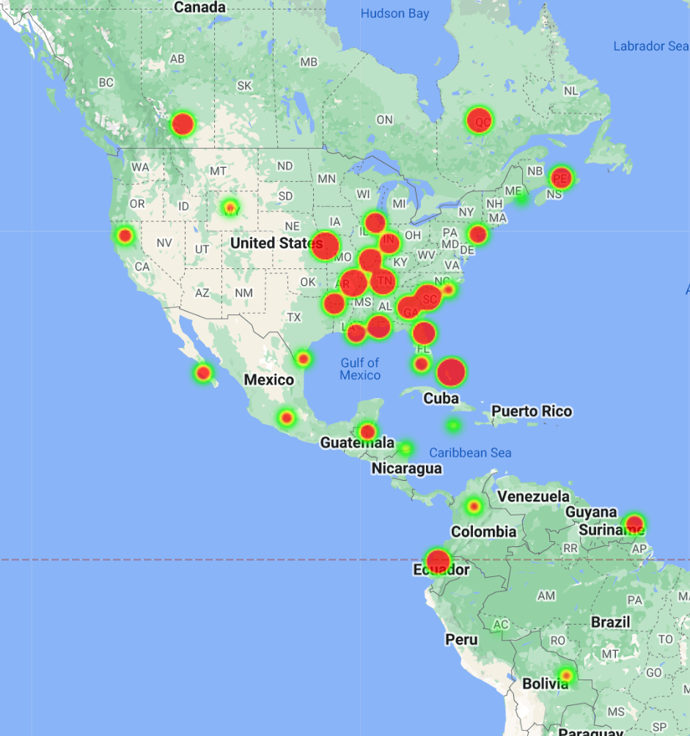
16. 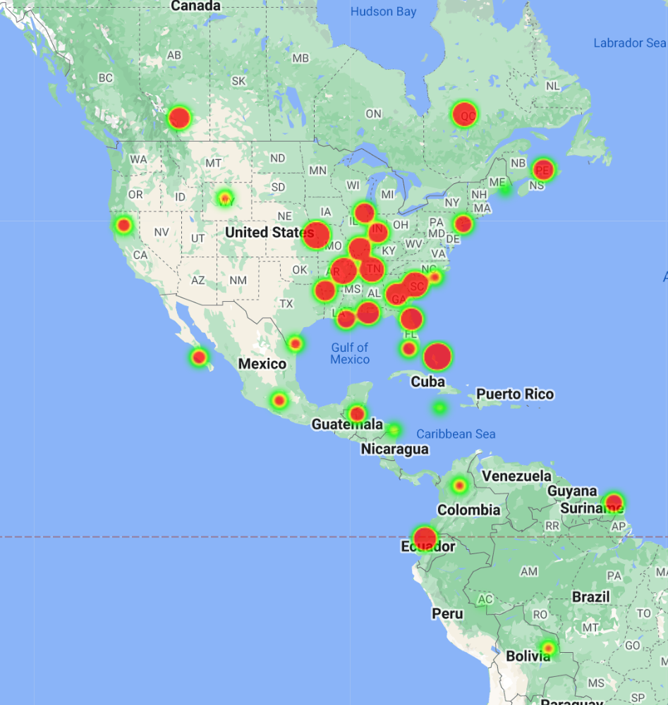
17. 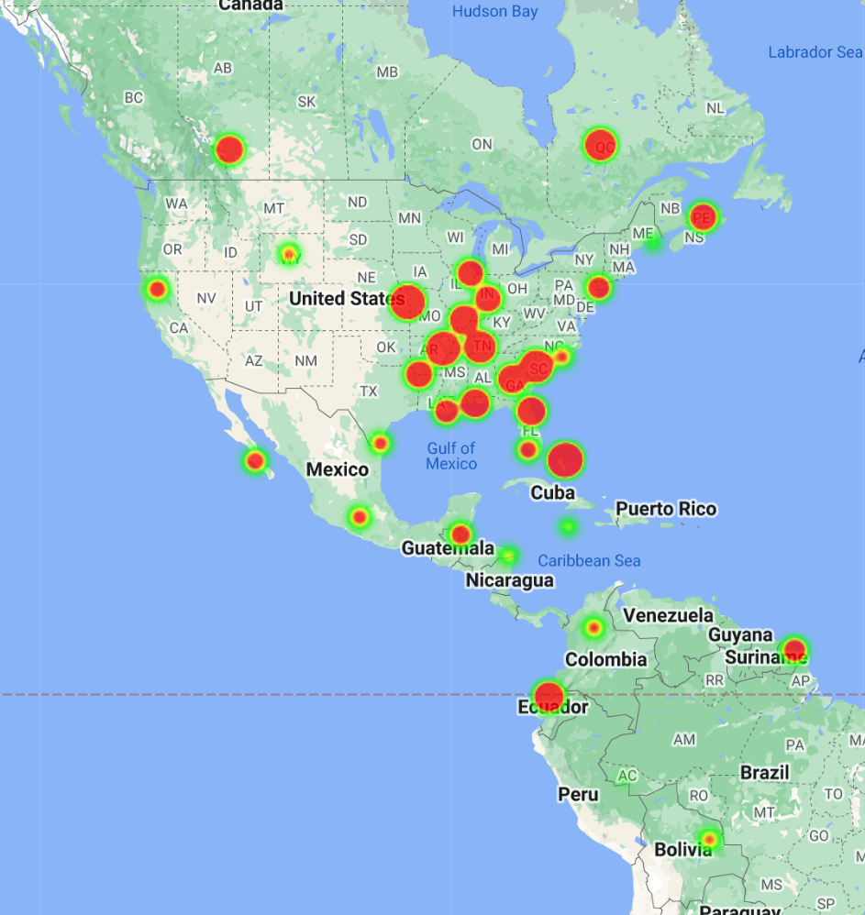
18. 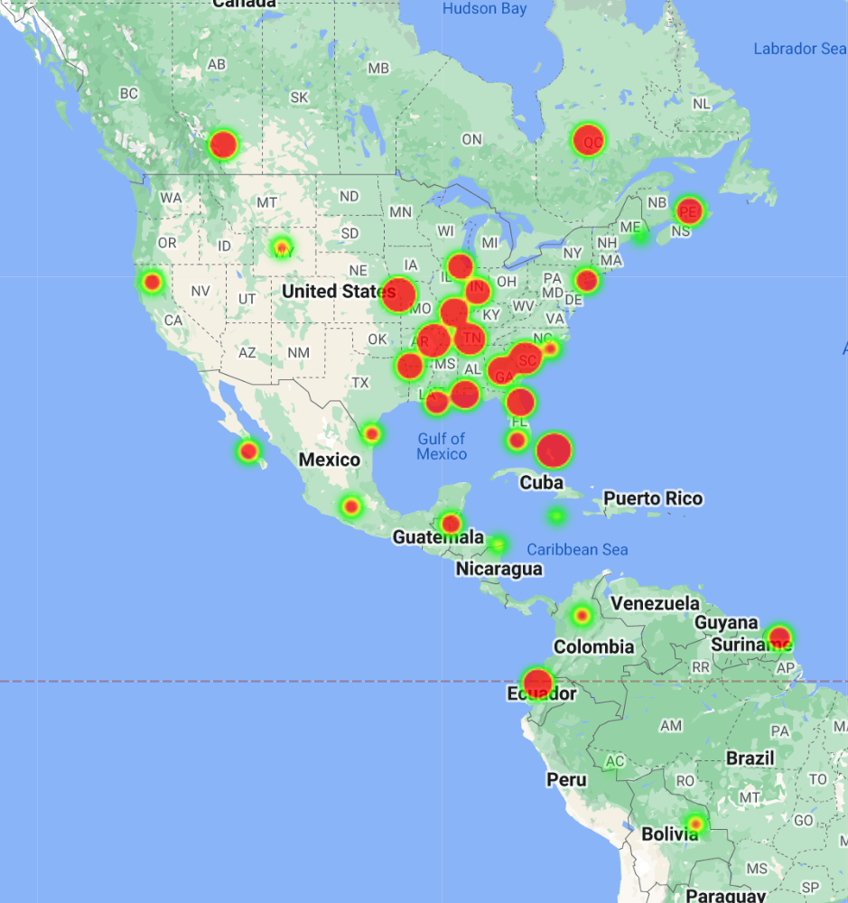
19. 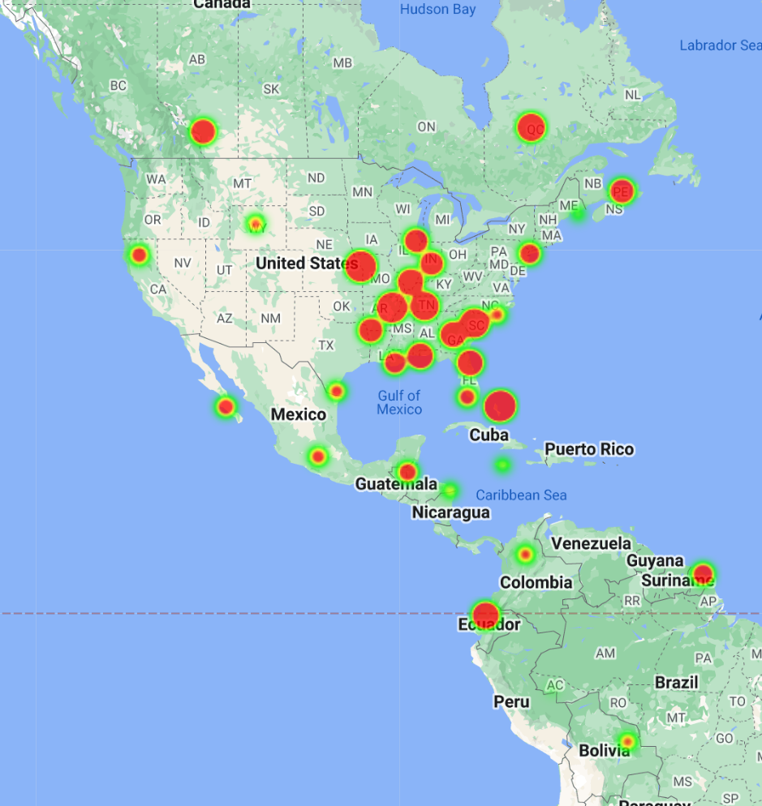
20. 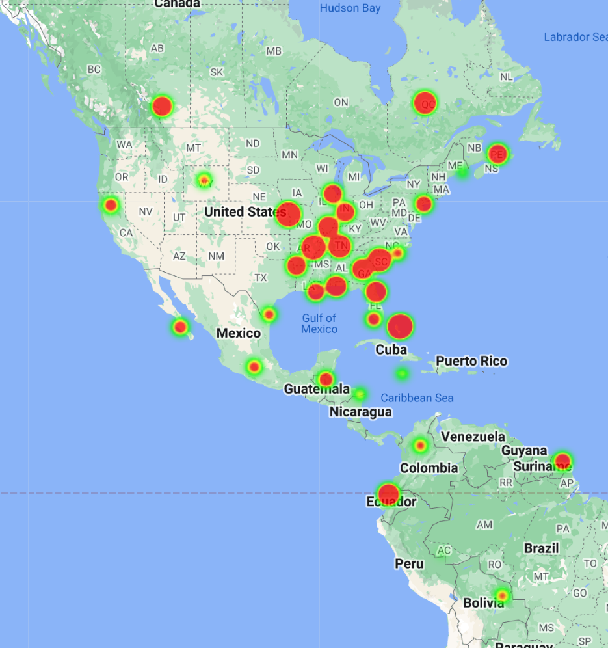
21. 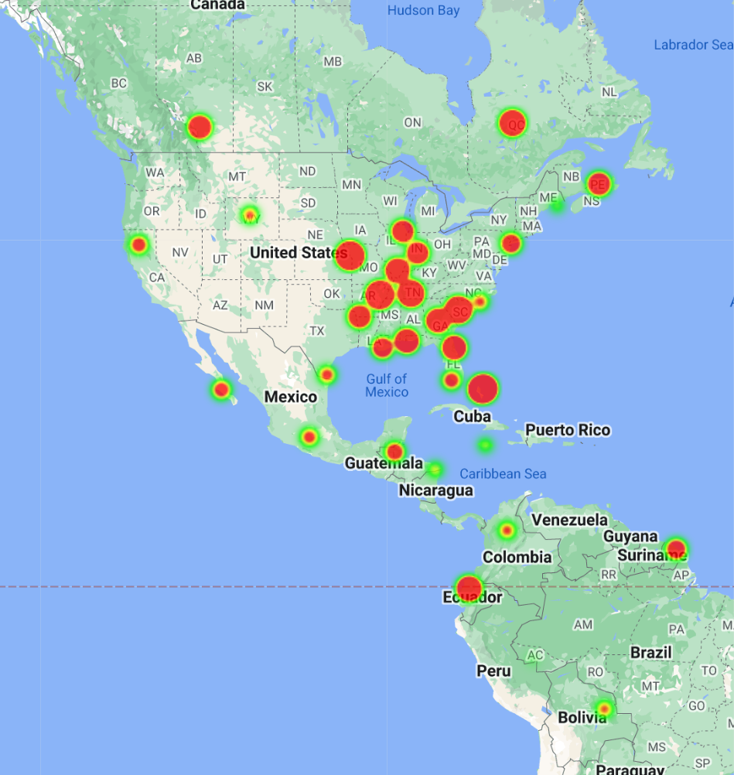
22. 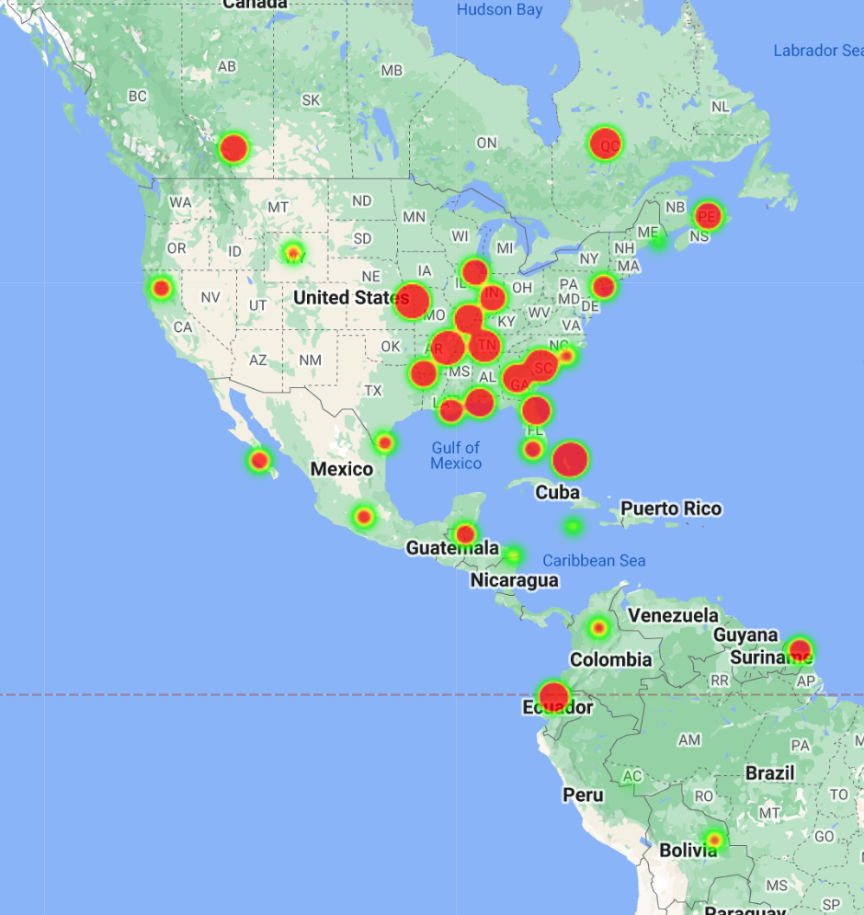
23. 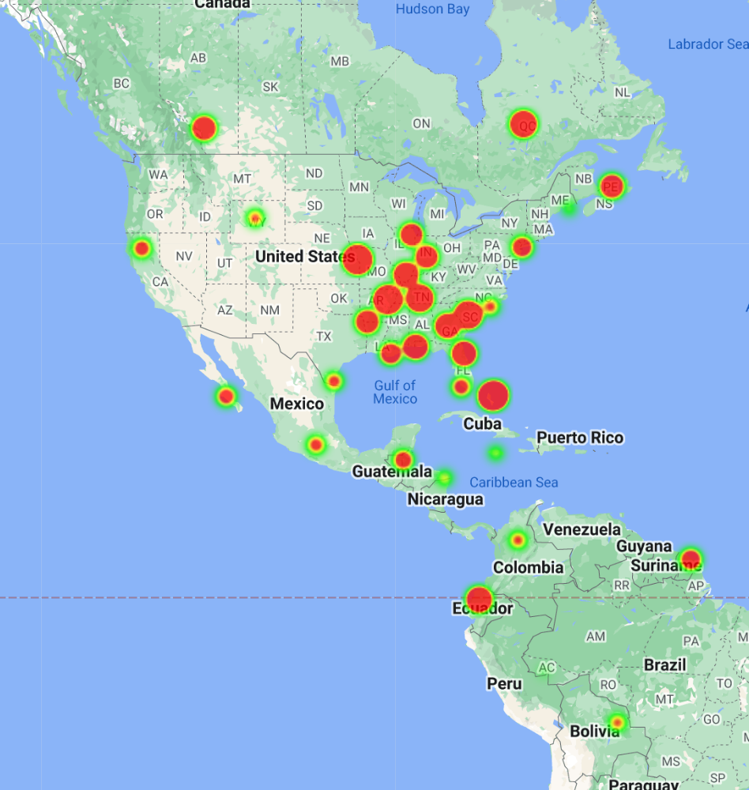
24. 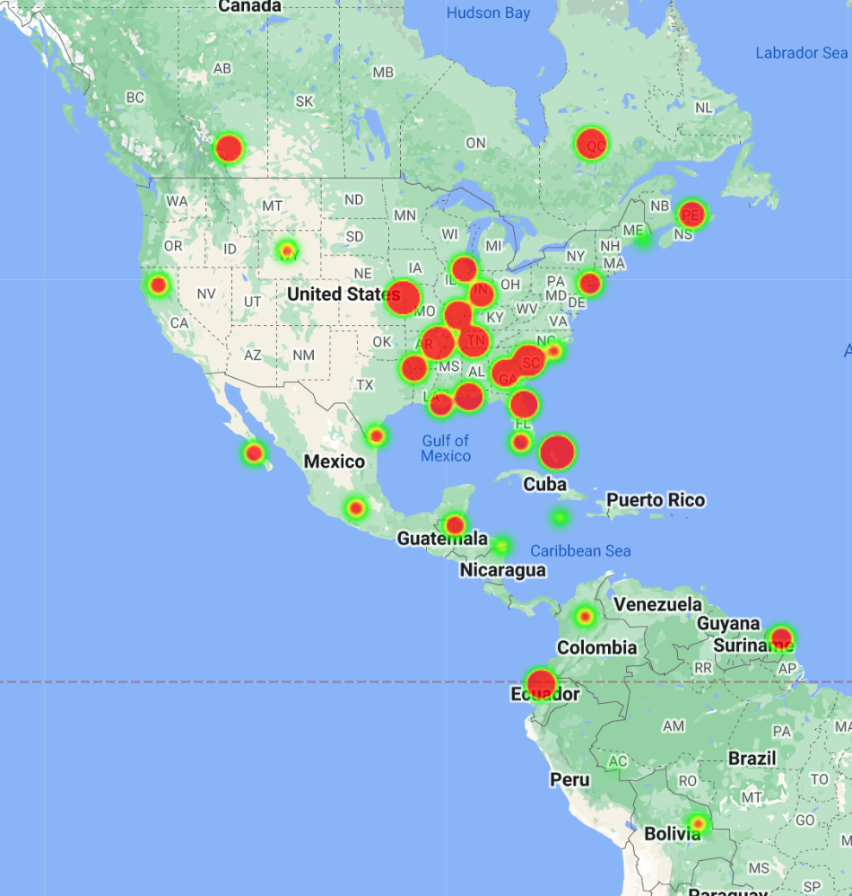
25. 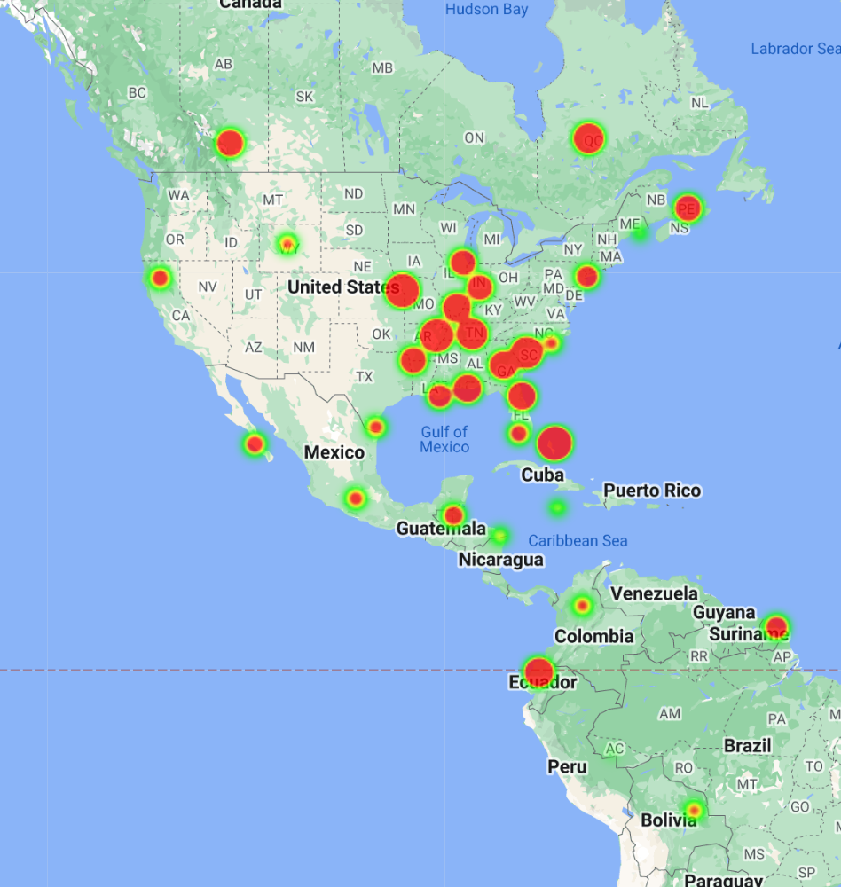
26. 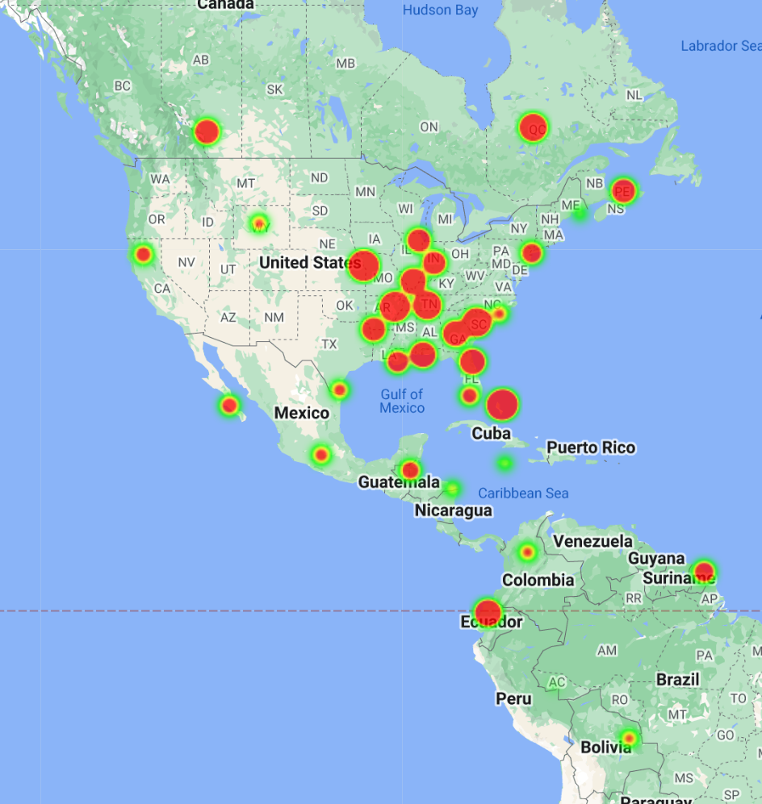
27. 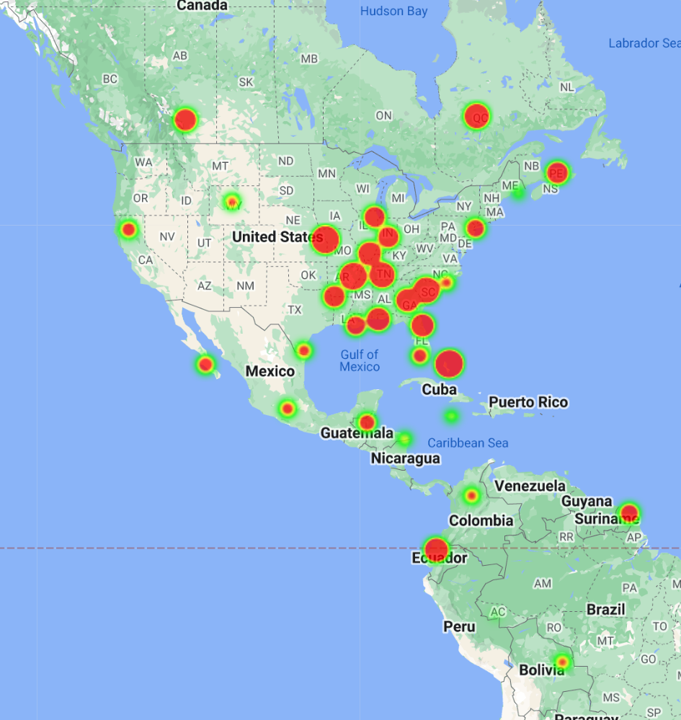
28. 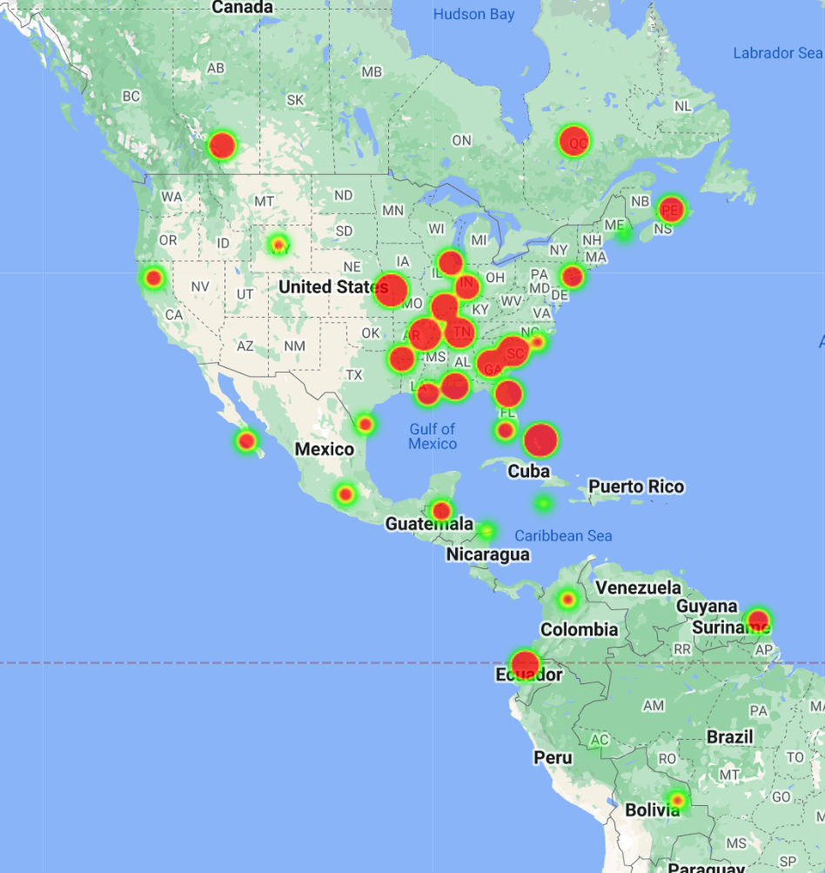
29. 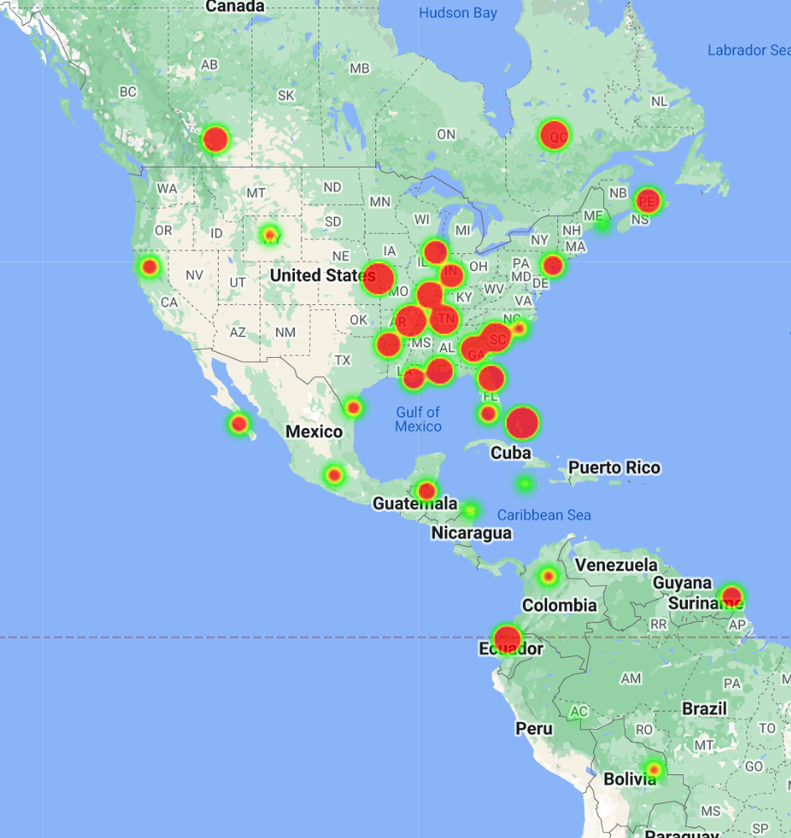
30. 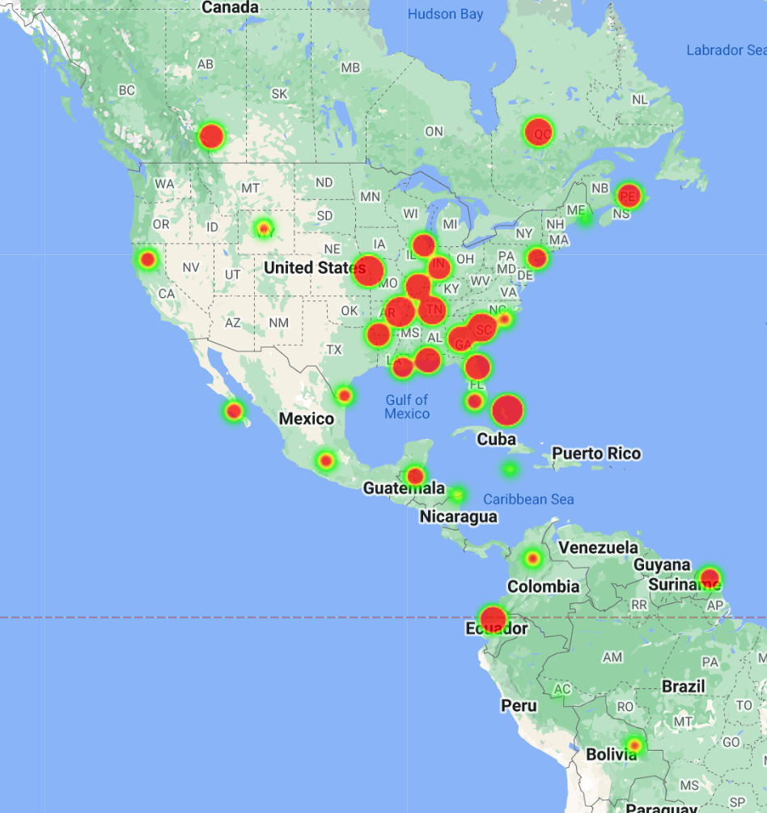
31. 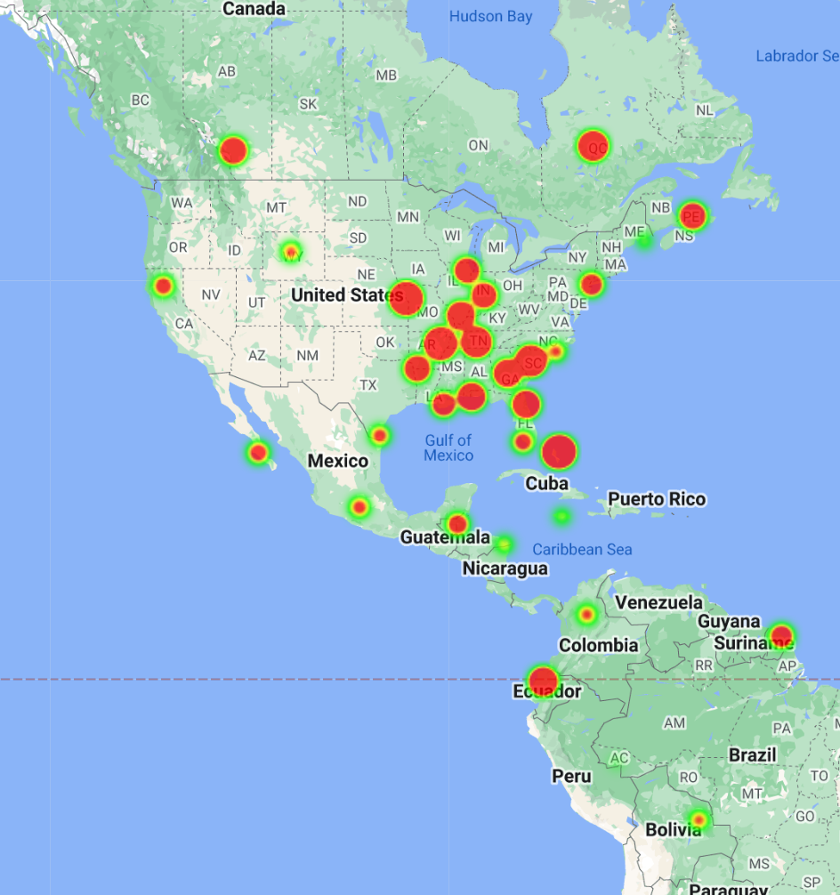
32. 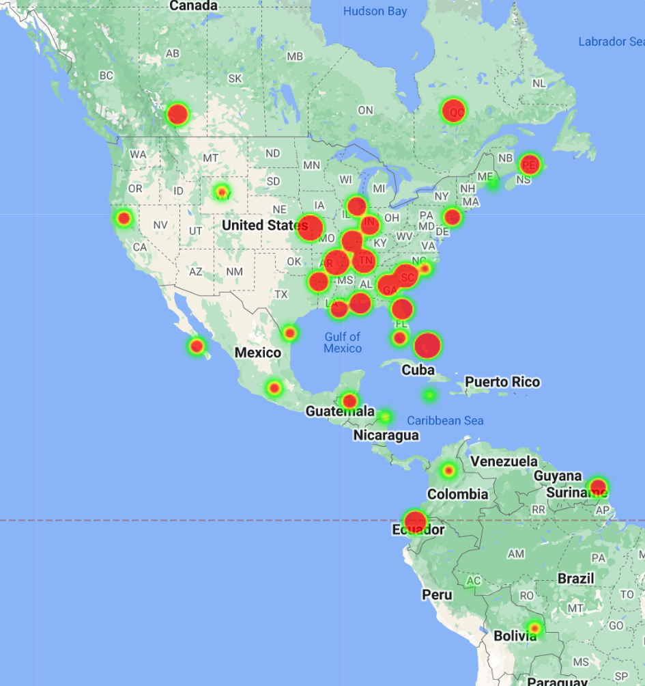
33. 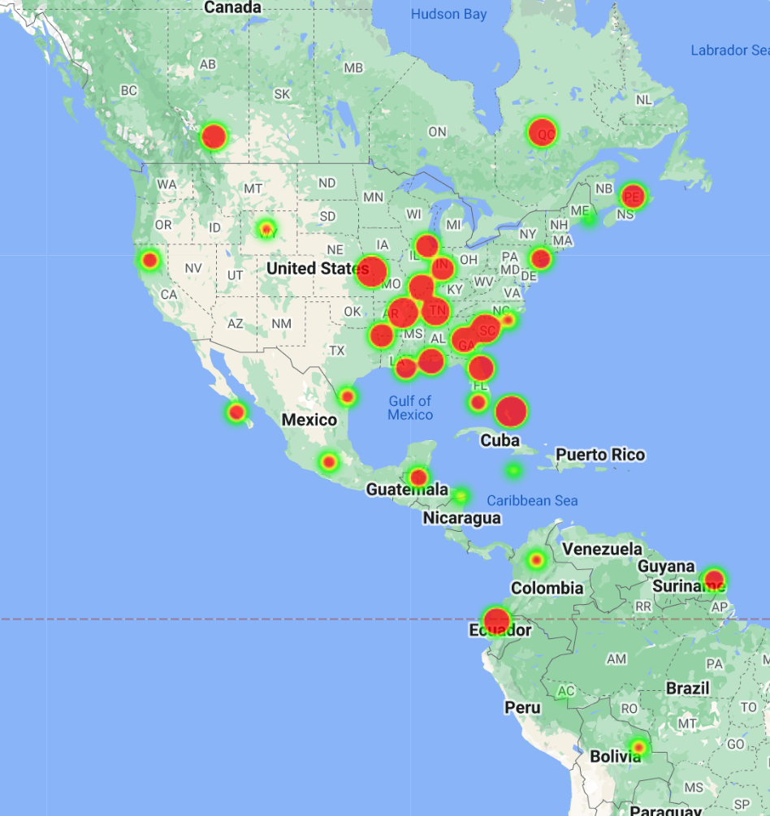
34. 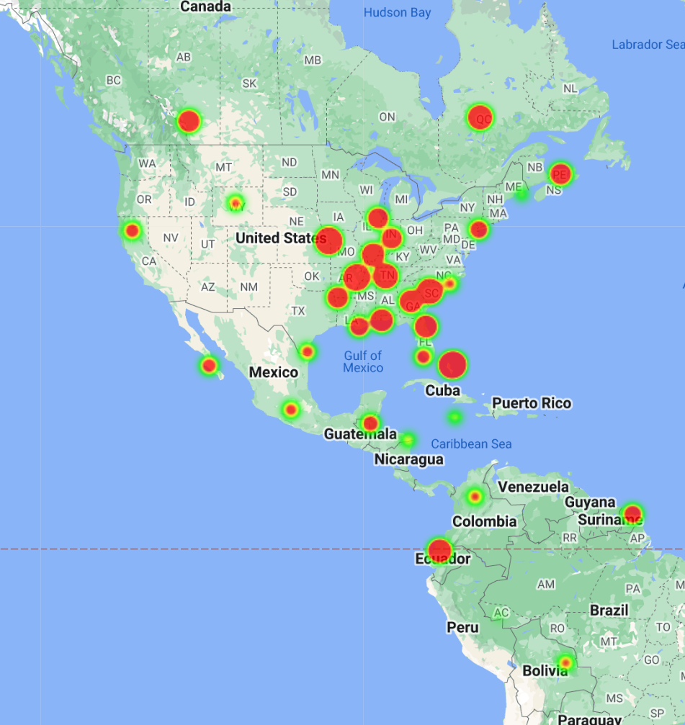
35. 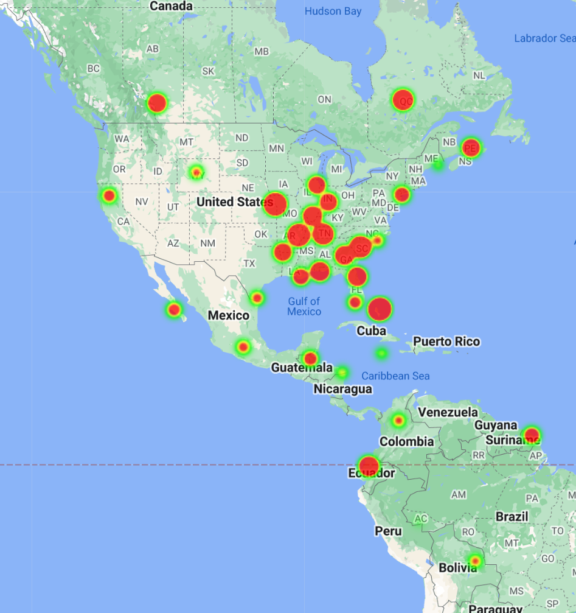
36. 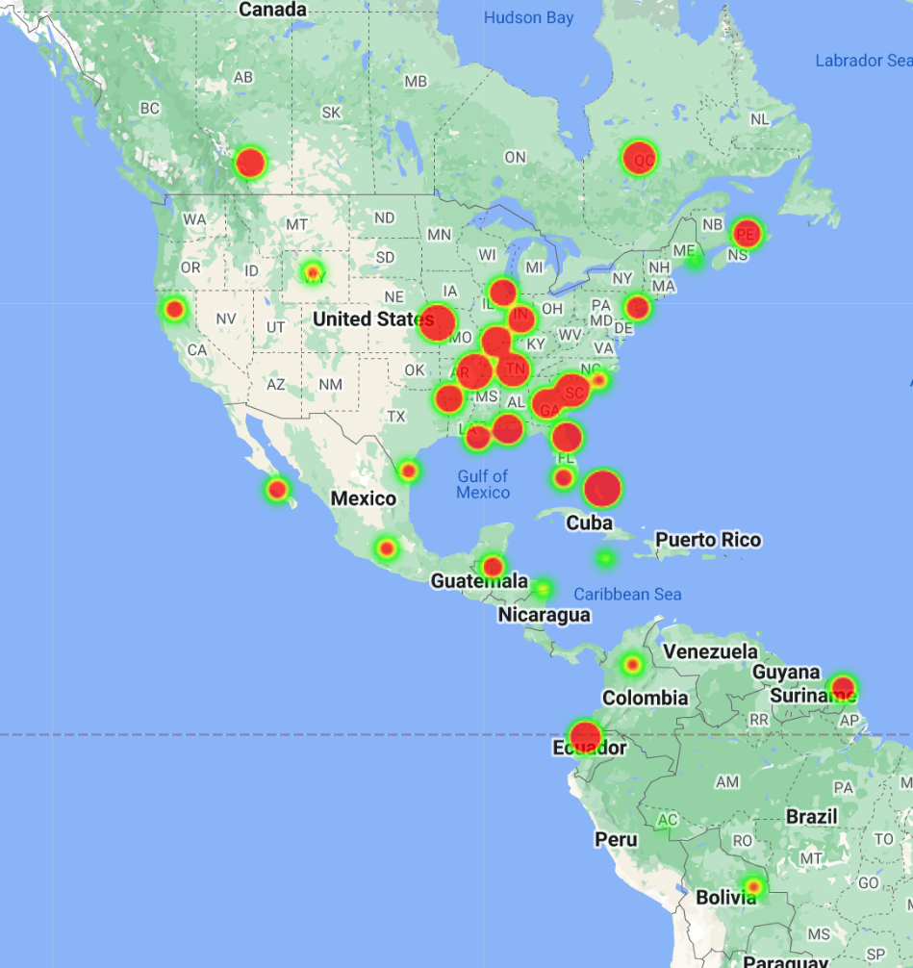
37. 